WEEK 1 TASK REPORT

Data Acquisition, Cleaning, and Exploratory Analysis

1. Introduction

Data preparation is one of the most important stages in a data science project. Before performing advanced analysis or developing machine learning models, raw data must be collected, inspected, cleaned, and understood. Poor-quality data can lead to inaccurate results and incorrect conclusions.
As part of the Week 1 task, a publicly available Titanic passenger dataset was selected for data acquisition, cleaning, preprocessing, and exploratory data analysis (EDA). Python, along with Pandas, NumPy, and Matplotlib, was used to perform the analysis in Google Colab.
The project focused on understanding the structure and quality of the dataset, identifying missing and duplicate records, checking data types, handling missing values, generating summary statistics, creating visualizations, and identifying important patterns in passenger survival.

2. Task Objective

The main objectives of this task were:
To acquire a publicly available dataset from the internet.
To understand the structure and characteristics of the dataset.
To identify missing values and determine appropriate methods for handling them.
To detect and remove duplicate records.
To examine and verify the data types of different variables.
To perform basic data preprocessing using Python.
To conduct exploratory data analysis.
To create meaningful visualizations to identify trends and relationships.
To calculate summary statistics and correlations.
To extract useful insights from the dataset.
To document the complete data preparation and analysis process.

3. Dataset Selection

For this project, the Titanic Passenger Dataset was selected.
The dataset contains information about passengers who travelled on the Titanic. It includes demographic and travel-related information along with a survival indicator.
The dataset contains 891 passenger records and 12 columns before cleaning.
Main variables in the dataset:
Column
Description
PassengerId
Unique passenger identification number
Survived
Survival status: 0 = Did not survive, 1 = Survived
Pclass
Passenger class: 1st, 2nd, or 3rd
Name
Passenger name
Sex
Passenger gender
Age
Passenger age
SibSp
Number of siblings/spouses aboard
Parch
Number of parents/children aboard
Ticket
Ticket number
Fare
Passenger fare
Cabin
Cabin information
Embarked
Port of embarkation

4. Tools and Technologies Used

The following tools and Python libraries were used:
Software
Google Colab
Python
Python Libraries
Pandas – Data loading, cleaning, preprocessing, and analysis
NumPy – Numerical operations
Matplotlib – Data visualization
The analysis was performed completely in a Google Colab environment.

5. Data Acquisition
The Titanic dataset was acquired from a publicly available online source using a direct CSV URL.
The dataset was loaded into Python using the Pandas read_csv() function.
Code Used:

import pandas as pd
import numpy as np
import matplotlib.pyplot as plt

# Load Titanic dataset from a public source
url = "https://raw.githubusercontent.com/datasciencedojo/datasets/master/titanic.csv"

df = pd.read_csv(url)

print("Dataset loaded successfully!")
print("Shape of dataset:", df.shape)

df.head()
Result
The dataset was successfully loaded.
Dataset shape:
Rows: 891
Columns: 12
The first five records were displayed using the head() function to verify that the dataset had been loaded correctly.

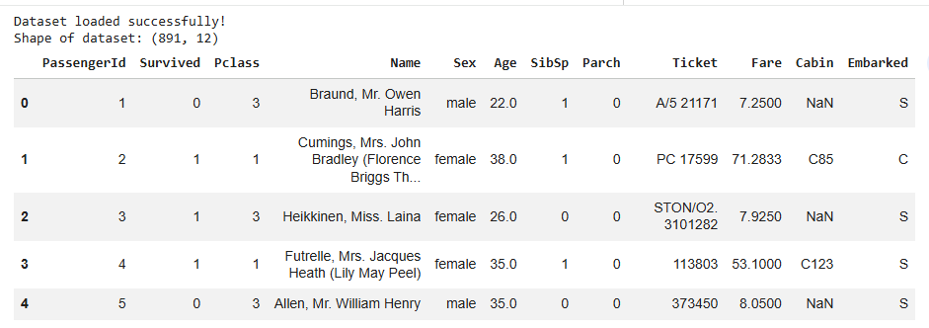

6. Data Understanding

After acquiring the dataset, its structure was examined using Pandas.
Code Used

print("Dataset Shape:")
print(df.shape)

print("\nColumn Names:")
print(df.columns.tolist())

print("\nDataset Information:")
df.info()
Results
The dataset contains:
891 rows
12 columns
5 integer columns
2 floating-point columns
5 object/text columns
The Age, Cabin, and Embarked columns contained missing values.
The data types were checked to ensure that numerical and categorical variables were represented appropriately.

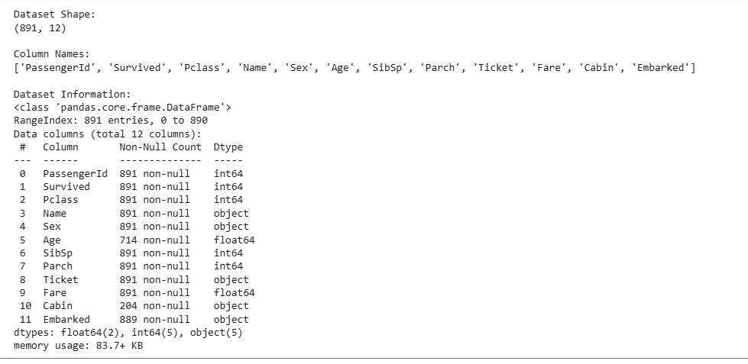

7. Missing Value Analysis

Missing values were identified using the isnull() function.
Code Used
missing_values = df.isnull().sum()

print("Missing values in each column:")
print(missing_values)

print("\nMissing value percentage:")
print((df.isnull().sum() / len(df) * 100).round(2))
Missing Value Results
Column
Missing Percentage
PassengerId
0.00%
Survived
0.00%
Pclass
0.00%
Name
0.00%
Sex
0.00%
Age
19.87%
SibSp
0.00%
Parch
0.00%
Ticket
0.00%
Fare
0.00%
Cabin
77.10%
Embarked
0.22%
The analysis showed that Age had 19.87% missing values, Cabin had 77.10% missing values, and Embarked had 0.22% missing values.
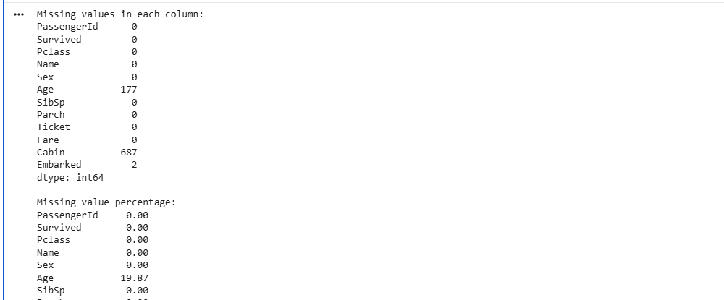
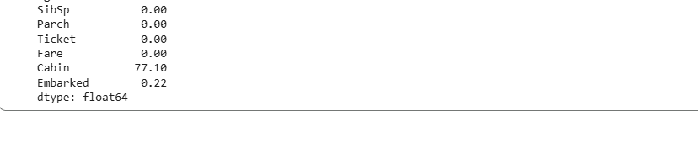

8. Missing Value Handling

Appropriate methods were selected based on the amount and nature of missing data.

8.1 Age
The missing values in the Age column were replaced using the median age.
The median was selected because it is less sensitive to extreme values than the mean and is therefore suitable for filling missing age values.

8.2 Embarked
Only a very small number of Embarked values were missing. These were replaced using the mode, which represents the most frequently occurring category.

8.3 Cabin
The Cabin column contained 77.10% missing values. Since such a large proportion of the column was missing, the column was removed from the cleaned dataset for this analysis.
Code Used

cleaned_df = df.copy()

# Fill missing Age values with the median
cleaned_df["Age"] = cleaned_df["Age"].fillna(cleaned_df["Age"].median())

# Fill missing Embarked values with the mode
cleaned_df["Embarked"] = cleaned_df["Embarked"].fillna(
cleaned_df["Embarked"].mode()[0]
)

# Remove Cabin because 77.10% of its values are missing
cleaned_df = cleaned_df.drop(columns=["Cabin"])

print("Missing values after cleaning:")
print(cleaned_df.isnull().sum())
After applying these methods, the remaining columns contained no missing values.

9. Duplicate Record Analysis

Duplicate records were checked using the Pandas duplicated() function.
Code Used
duplicate_count = df.duplicated().sum()

print("Number of duplicate rows:", duplicate_count)
Result
The analysis identified:
Number of duplicate rows: 0
Therefore, no duplicate records were present in the original dataset.
For completeness, the duplicate-removal operation was also applied to the cleaned dataset.
before = len(cleaned_df)

cleaned_df = cleaned_df.drop_duplicates()

after = len(cleaned_df)

print("Rows before removing duplicates:", before)
print("Rows after removing duplicates:", after)
print("Duplicates removed:", before - after)
The dataset remained at 891 rows, confirming that no duplicate records were removed.

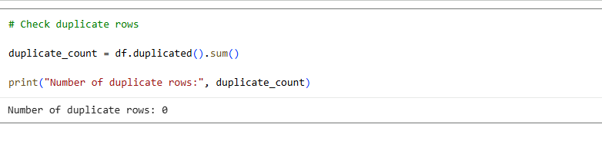

10. Data Type Analysis

The data types of all columns were examined.
Code Used

print("Data types of each column:")
print(df.dtypes)
The dataset contained:
Integer variables such as PassengerId, Survived, Pclass, SibSp, and Parch.
Floating-point variables such as Age and Fare.
Object/string variables such as Name, Sex, Ticket, Cabin, and Embarked.
The data types were considered appropriate for the intended analysis.

11. Summary Statistics

Descriptive statistics were generated using the describe() function.
Code Used

print("Summary Statistics:")
display(df.describe())
The summary statistics included:
Count
Mean
Standard deviation
Minimum
25th percentile
Median
75th percentile
Maximum
These statistics provided an initial understanding of the numerical characteristics of the dataset.
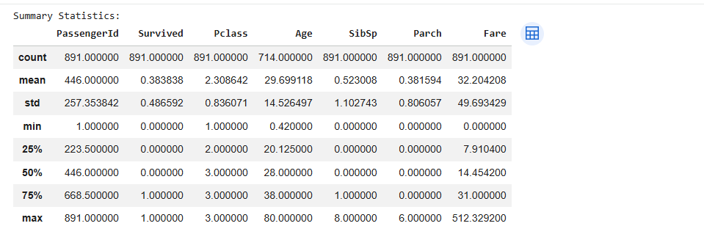

12. Final Data Cleaning Verification

After cleaning, the dataset was verified to ensure that the preprocessing steps were successful.

Code Used
print("Cleaned dataset shape:")
print(cleaned_df.shape)

print("\nRemaining missing values:")
print(cleaned_df.isnull().sum())

print("\nData types:")
print(cleaned_df.dtypes)

print("\nFirst 5 rows of cleaned dataset:")
display(cleaned_df.head())

The cleaned dataset contained:
891 rows
11 columns

The reduction from 12 to 11 columns occurred because the Cabin column was removed due to its high percentage of missing values.
All remaining missing values were successfully handled.

13. Exploratory Data Analysis
Exploratory Data Analysis was performed to identify patterns, distributions, and relationships within the dataset.
Five visualizations were created:
Passenger Survival Distribution
Age Distribution
Survival Rate by Passenger Class
Survival Rate by Gender
Correlation Matrix

14. Visualization 1 — Passenger Survival Distribution

The first visualization shows the number of passengers who survived compared with those who did not survive.
Code Used
survival_counts = cleaned_df["Survived"].value_counts().sort_index()

plt.figure(figsize=(7, 5))
plt.bar(["Did Not Survive", "Survived"], survival_counts.values)

plt.title("Passenger Survival Distribution")
plt.xlabel("Survival Status")
plt.ylabel("Number of Passengers")

plt.show()

Observation
The analysis showed that 342 passengers survived, giving an overall survival rate of 38.38%.
This indicates that the majority of passengers in the dataset did not survive the incident.
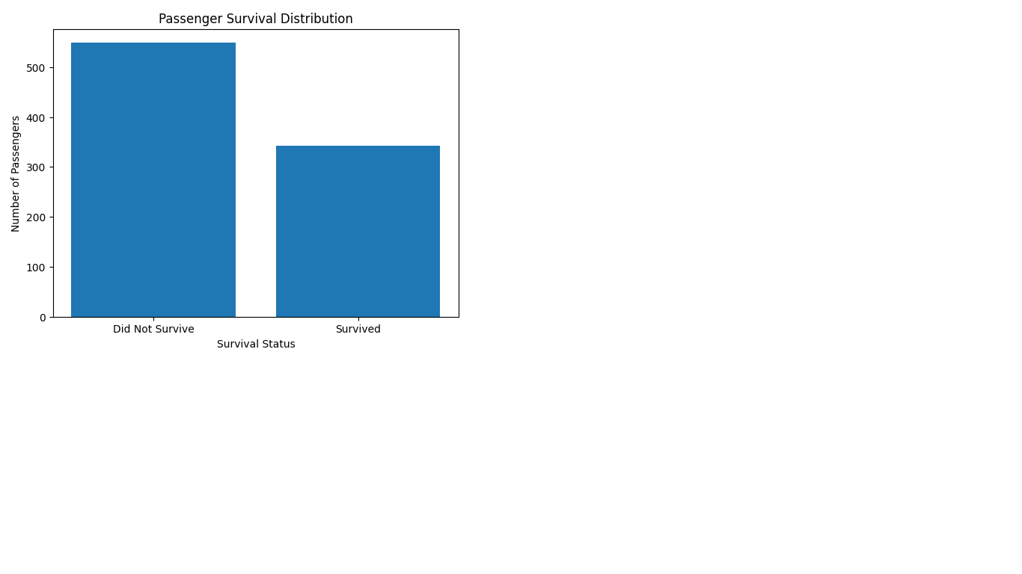
Figure 1: Passenger Survival Distribution

15. Visualization 2 — Age Distribution
A histogram was created to understand the distribution of passenger ages.

Code Used
plt.figure(figsize=(8, 5))

plt.hist(cleaned_df["Age"], bins=20)

plt.title("Age Distribution of Passengers")
plt.xlabel("Age")
plt.ylabel("Number of Passengers")

plt.show()
Observation
The average passenger age after missing-value treatment was approximately 29.36 years.
The histogram shows that passengers were distributed across a wide range of ages, with a larger concentration around the younger and middle-age groups.
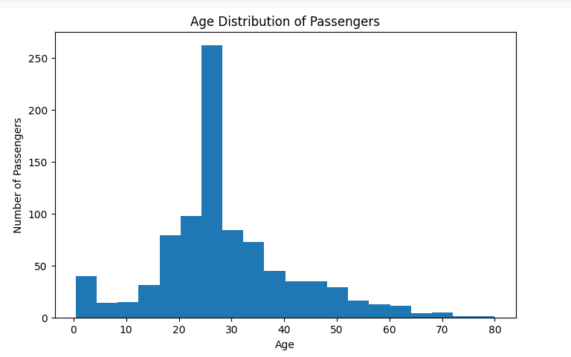
Figure 2: Age Distribution of Passengers

16. Visualization 3 — Survival Rate by Passenger Class
The survival rate for each passenger class was calculated and visualized.
Code Used

survival_by_class = cleaned_df.groupby("Pclass")["Survived"].mean() * 100

plt.figure(figsize=(7, 5))
plt.bar(["1st Class", "2nd Class", "3rd Class"], survival_by_class.values)

plt.title("Survival Rate by Passenger Class")
plt.xlabel("Passenger Class")
plt.ylabel("Survival Rate (%)")

plt.show()
Results
Passenger Class
Survival Rate
1st Class
62.96%
2nd Class
47.28%
3rd Class
24.24%
Observation
The survival rate was highest among 1st-class passengers at 62.96%.
The survival rate decreased to 47.28% for 2nd-class passengers and 24.24% for 3rd-class passengers.
This indicates a strong relationship between passenger class and survival in this dataset.
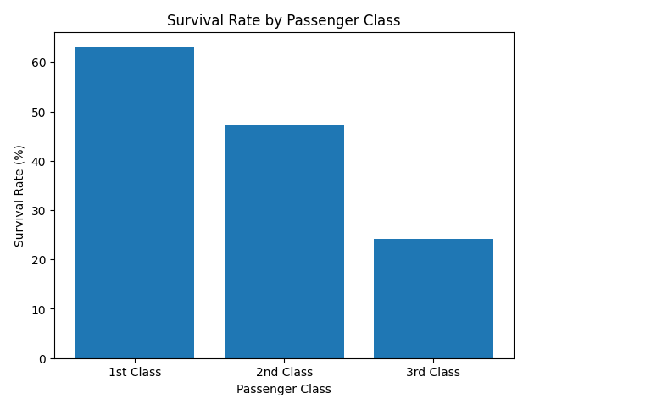Figure 3: Survival Rate by Passenger Class

17. Visualization 4 — Survival Rate by Gender

The survival rate was also analyzed based on passenger gender.
Code Used
survival_by_gender = cleaned_df.groupby("Sex")["Survived"].mean() * 100

plt.figure(figsize=(7, 5))
plt.bar(["Female", "Male"], survival_by_gender.values)

plt.title("Survival Rate by Gender")
plt.xlabel("Gender")
plt.ylabel("Survival Rate (%)")

plt.show()
Results
Gender
Survival Rate
Female
74.20%
Male
18.89%
Observation
Female passengers had a survival rate of 74.20%, while male passengers had a survival rate of 18.89%.
The difference is substantial and indicates that gender was strongly associated with survival outcomes in the dataset.
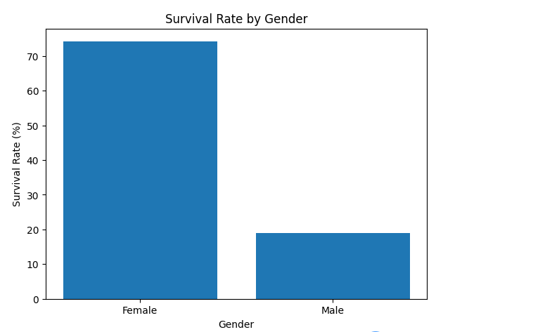
Figure 4: Survival Rate by Gender

18. Visualization 5 — Correlation Analysis

A correlation matrix was generated for the numerical variables.
Code Used
numeric_df = cleaned_df.select_dtypes(include=np.number)

correlation = numeric_df.corr()

print("Correlation Matrix:")
display(correlation.round(2))
The correlation matrix was then visualized using:
plt.figure(figsize=(9, 7))

plt.imshow(correlation, aspect="auto")
plt.colorbar()

plt.xticks(
range(len(correlation.columns)),
correlation.columns,
rotation=45
)

plt.yticks(
range(len(correlation.columns)),
correlation.columns
)

plt.title("Correlation Matrix of Numerical Variables")

plt.tight_layout()
plt.show()
Observation
The correlation analysis helps identify relationships between numerical variables. In particular, the relationship between Survived and Pclass can be examined to understand how passenger class is associated with survival.
Correlation analysis provides an initial indication of relationships, although correlation alone does not establish causation.
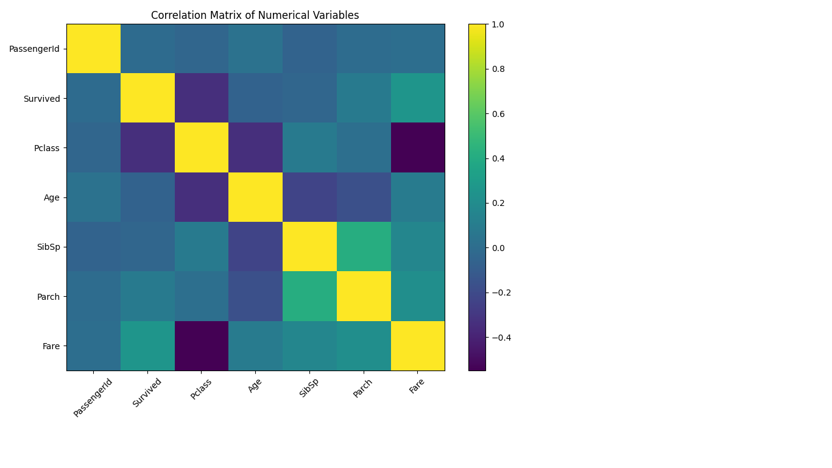
Figure 5: Correlation Matrix of Numerical Variables

19. Key Analytical Insights

The major findings from the exploratory analysis are summarized below.

19.1 Overall Survival
Out of 891 passengers, 342 passengers survived.
The overall survival rate was:
38.38%
This means that fewer than half of the passengers in the dataset survived.

19.2 Passenger Class
Passenger class showed a clear difference in survival rates:
1st Class: 62.96%
2nd Class: 47.28%
3rd Class: 24.24%
The highest survival rate was observed among 1st-class passengers, while the lowest was observed among 3rd-class passengers.

19.3 Gender
Gender showed a substantial difference in survival:
Female: 74.20%
Male: 18.89%
Female passengers had a considerably higher survival rate than male passengers in this dataset.

19.4 Age
The average passenger age was approximately 29.36 years.
The age histogram indicates that the dataset contains passengers from a broad range of age groups.

19.5 Fare
The average passenger fare was approximately 32.20.
Fare can be considered alongside passenger class for further analysis because different passenger classes generally represented different travel conditions.

20. Data Cleaning Rationale

The cleaning methods were selected based on the characteristics of each variable.

Data Issue | Method Used | Reason
Missing age | Median imputation | Reduces the influence of extreme values
Missing Embarked | Mode imputation | Very few missing categorical values
Missing Cabin | Column removed | 77.10% of values were missing
Duplicate records | Checked and removed if present | Ensures unique records
Data types | Inspected | Ensures variables are suitable for analysis

The cleaning methods were selected based on the characteristics of each variable.

These methods allowed the dataset to be prepared while retaining the maximum amount of useful information.

21. Challenges and Solutions

Challenge 1: Missing Values
Several columns contained missing values, particularly Cabin and Age.
Solution: Missing numerical values in Age were replaced with the median, while missing categorical values in Embarked were replaced with the mode. The Cabin column was removed because most of its values were missing.

Challenge 2: Understanding Dataset Structure
Before analysis, it was necessary to understand the columns and their data types.
Solution: Pandas functions such as shape, columns, info(), and dtypes were used.

Challenge 3: Identifying Meaningful Patterns
Raw numerical values alone do not easily reveal relationships.
Solution: Visualizations such as bar charts, histograms, and a correlation matrix were used to make important patterns easier to interpret.

22. Technologies and Libraries

The project was implemented using:
Python: Main programming language.
Pandas: Used for dataset loading, cleaning, transformation, grouping, and statistical analysis.
NumPy: Used for numerical operations and selecting numerical variables for correlation analysis.
Matplotlib: Used to generate charts and visualizations.
Google Colab: Used as the development and execution environment.

23. Conclusion

This Week 1 project successfully demonstrated the fundamental stages of data preparation and exploratory data analysis using Python.
A publicly available Titanic passenger dataset containing 891 records and 12 columns was acquired and examined. Missing values were identified and handled using appropriate techniques. The Age column was processed using median imputation, missing Embarked values were replaced using the mode, and the Cabin column was removed because of its high proportion of missing data. Duplicate records were also checked, and no duplicates were found.
Exploratory analysis was performed using summary statistics and five visualizations. The analysis revealed an overall survival rate of 38.38%. Passenger class and gender showed substantial differences in survival rates. First-class passengers had a survival rate of 62.96%, compared with 24.24% for third-class passengers. Female passengers had a survival rate of 74.20%, compared with 18.89% for male passengers.
Overall, this project provided practical experience in data acquisition, data cleaning, preprocessing, visualization, and interpretation. The cleaned dataset and analytical findings can serve as a foundation for more advanced statistical analysis or machine learning tasks in future work.

24. Complete Python Code

You can place the complete code at the end of your report under this section.
import pandas as pd
import numpy as np
import matplotlib.pyplot as plt

# Data Acquisition
url = "https://raw.githubusercontent.com/datasciencedojo/datasets/master/titanic.csv"
df = pd.read_csv(url)

print("Dataset loaded successfully!")
print("Shape of dataset:", df.shape)

df.head()

# Data Understanding
print("Dataset Shape:")
print(df.shape)

print("\nColumn Names:")
print(df.columns.tolist())

print("\nDataset Information:")
df.info()

# Missing Value Analysis
missing_values = df.isnull().sum()

print("Missing values in each column:")
print(missing_values)

print("\nMissing value percentage:")
print((df.isnull().sum() / len(df) * 100).round(2))

# Duplicate Check
duplicate_count = df.duplicated().sum()

print("Number of duplicate rows:", duplicate_count)

# Data Types
print("Data types of each column:")
print(df.dtypes)

# Summary Statistics
print("Summary Statistics:")
display(df.describe())

# Data Cleaning
cleaned_df = df.copy()

cleaned_df["Age"] = cleaned_df["Age"].fillna(
cleaned_df["Age"].median()
)

cleaned_df["Embarked"] = cleaned_df["Embarked"].fillna(
cleaned_df["Embarked"].mode()[0]
)

cleaned_df = cleaned_df.drop(columns=["Cabin"])

# Remove duplicates
before = len(cleaned_df)

cleaned_df = cleaned_df.drop_duplicates()

after = len(cleaned_df)

print("Rows before removing duplicates:", before)
print("Rows after removing duplicates:", after)
print("Duplicates removed:", before - after)

# Final Verification
print("Cleaned dataset shape:")
print(cleaned_df.shape)

print("\nRemaining missing values:")
print(cleaned_df.isnull().sum())

print("\nData types:")
print(cleaned_df.dtypes)

display(cleaned_df.head())

# Visualization 1
survival_counts = cleaned_df["Survived"].value_counts().sort_index()

plt.figure(figsize=(7, 5))
plt.bar(["Did Not Survive", "Survived"], survival_counts.values)
plt.title("Passenger Survival Distribution")
plt.xlabel("Survival Status")
plt.ylabel("Number of Passengers")
plt.show()

# Visualization 2
plt.figure(figsize=(8, 5))
plt.hist(cleaned_df["Age"], bins=20)
plt.title("Age Distribution of Passengers")
plt.xlabel("Age")
plt.ylabel("Number of Passengers")
plt.show()

# Visualization 3
survival_by_class = cleaned_df.groupby("Pclass")["Survived"].mean() * 100

plt.figure(figsize=(7, 5))
plt.bar(
["1st Class", "2nd Class", "3rd Class"],
survival_by_class.values
)
plt.title("Survival Rate by Passenger Class")
plt.xlabel("Passenger Class")
plt.ylabel("Survival Rate (%)")
plt.show()

# Visualization 4
survival_by_gender = cleaned_df.groupby("Sex")["Survived"].mean() * 100

plt.figure(figsize=(7, 5))
plt.bar(["Female", "Male"], survival_by_gender.values)
plt.title("Survival Rate by Gender")
plt.xlabel("Gender")
plt.ylabel("Survival Rate (%)")
plt.show()

# Correlation Analysis
numeric_df = cleaned_df.select_dtypes(include=np.number)
correlation = numeric_df.corr()

print("Correlation Matrix:")
display(correlation.round(2))

# Visualization 5
plt.figure(figsize=(9, 7))
plt.imshow(correlation, aspect="auto")
plt.colorbar()

plt.xticks(
range(len(correlation.columns)),
correlation.columns,
rotation=45
)

plt.yticks(
range(len(correlation.columns)),
correlation.columns
)

plt.title("Correlation Matrix of Numerical Variables")
plt.tight_layout()
plt.show()

# Key Insights
total_passengers = len(cleaned_df)
survived_count = cleaned_df["Survived"].sum()
survival_rate = cleaned_df["Survived"].mean() * 100

class_survival = cleaned_df.groupby("Pclass")["Survived"].mean() * 100
gender_survival = cleaned_df.groupby("Sex")["Survived"].mean() * 100

average_age = cleaned_df["Age"].mean()
average_fare = cleaned_df["Fare"].mean()

print("KEY INSIGHTS")
print("-" * 40)

print(f"Total passengers analysed: {total_passengers}")
print(f"Passengers survived: {survived_count}")
print(f"Overall survival rate: {survival_rate:.2f}%")
print(f"Average passenger age: {average_age:.2f} years")
print(f"Average fare: {average_fare:.2f}")

print("\nSurvival rate by passenger class:")
print(class_survival.round(2))

print("\nSurvival rate by gender:")
print(gender_survival.round(2))

# Save cleaned dataset
cleaned_df.to_csv("cleaned_titanic_dataset.csv", index=False)

print("Cleaned Titanic dataset saved successfully.")

25. References

- Publicly available Titanic passenger dataset.
- Python Pandas documentation.
- NumPy documentation.
- Matplotlib documentation.
- Google Colab environment.

